October 2019

Dear Parents and Carers

Year 11 Parents’ Update

The students have had a very positive start to the year and as we now approach the first round of PPE examinations, I thought it a prudent time to write and communicate some recent and upcoming events, along with details of how we can support you and your child over the coming months.

Parents’ Information Evening
We ran an evening in September which was attended by over 230 parents and students. We know many parents wanted to attend but were unable, so the presentations can be found on the Priory website. Please go to:
- Students
- Examination Information
- Parents’ Information Evening

Revision folders and record cards
Students are encouraged to keep revision folders and some record cards to help them organise their revision. They will be completing revision cards in tutor time in preparation. If there is one resource that will support your child’s revision above any other it would be record cards, so we would urge them to buy some.

Parent APP
We have introduced an app for your mobile phone designed to help keep you in touch with your child’s education. We want as many parents as possible to use the app because we think it will help you to understand how your child is progressing. Go to https://www.myedschoolapp.com/

Pre Public Examinations (PPEs)
These begin on 11 November and last for two weeks followed by the Art exams in the third week. This is our first round of “Mock Examinations”. This process is to provide students with an authentic examination experience and staff with further evidence of areas of strength and development to aid planning in the final months. Students will have to work hard and manage their time well, but we also understand that we need to help them manage that time. The PPE Timetable has been shared with your child and can be found on our website at:
https://www.priorysouthsea.org/students/exam-information/

With exams and wellbeing in mind we have decided that students may leave school early if they have an exam in the afternoon. This time may vary in length but will support their wellbeing. If students wish to remain and attend the last part of their period 5/ 6 lesson they may do so but that will be optional.

Parents’ Evening 19 December 2019
This evening serves two purposes; first to provide you with examination results from the PPE exams and secondly, the opportunity to meet staff and understand how you might best support your child in their final months.

We urge all parents to make every effort to attend. Parents that attended last year’s evening found it enormously helpful.

…../2
The grades that students receive at this stage of Year 11 are often significantly lower than their final GCSE grades and we go to some lengths to explain this on the evening.

Period 7
Period seven sessions will not run during the PPEs.

Homework
We expect students to be revising at home during the PPEs and tasks will be set to aid this. There will be no homework set for the two weeks immediately following the PPEs.

Other important dates for this half term

INSET Days
Tuesday 26 November
Monday 9 December

School closed to all students on these days. No clubs or after school lessons will run on these days.

Final day of the Autumn term

Friday 20 December - School will close at 12.30pm. Students who receive Free School Meals are able to collect their lunch during the mid-morning break.

First day of the Spring term 2020

6 January 2020 - All students return to school.

Dance Show 17 & 18 December

This is a delightful evening showcasing the artistic talents at Priory School and we would love to see you on one of these evenings. Shows will be at 4.30 & 7.30pm, tickets will be on sale from reception in the near future. Please check our Facebook page for updates.

Thank you for your continued support at this crucial time in your child’s education.

Yours sincerely
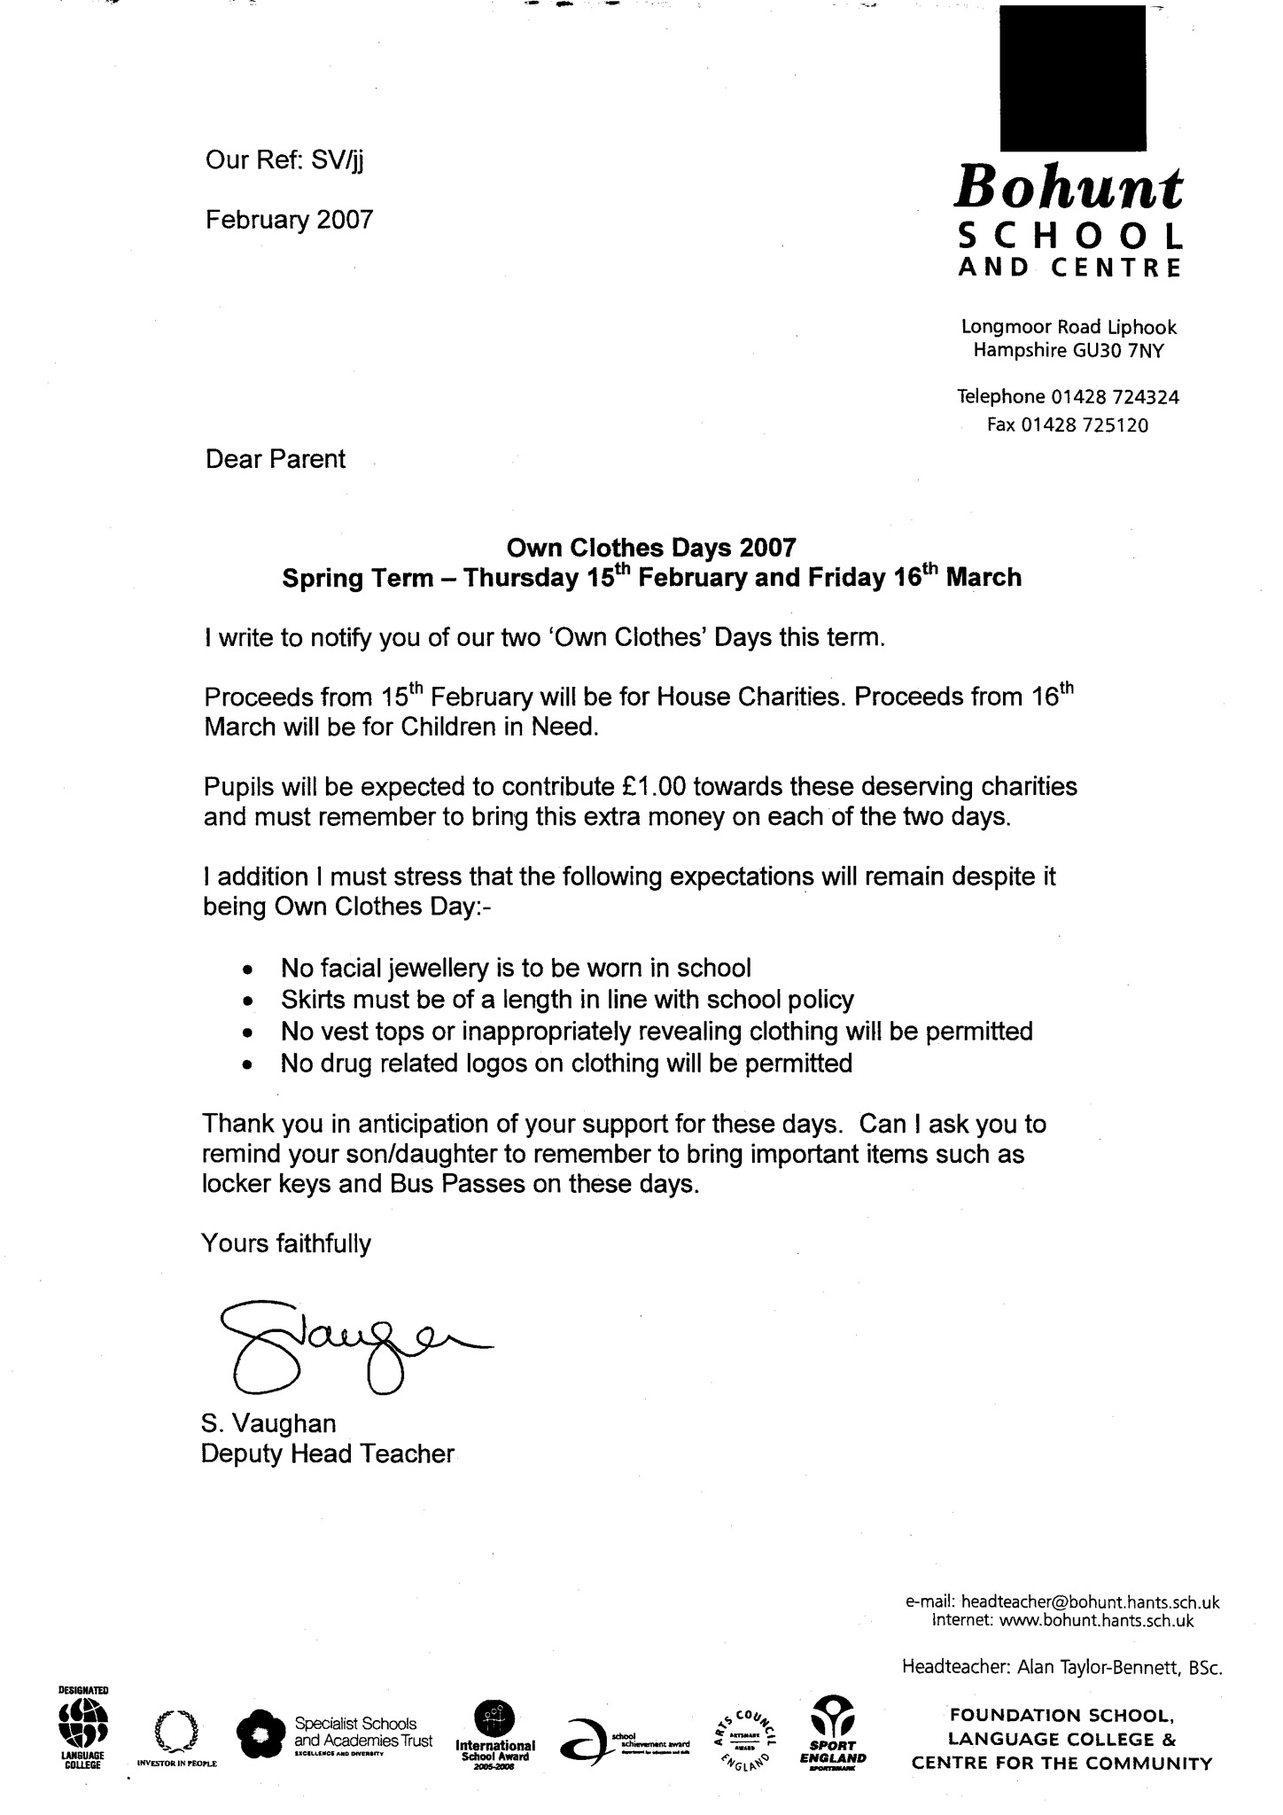

S Vaughan

Headteacher

