02 March 2020

Dear Parents & Carers

Re: COVID–19 Further advice for parents and carers

Further to our letter of 26 February we are acutely aware of the current level of concern about the risks from coronavirus and the subsequent confirmed cases in the UK.

Across Bohunt Education Trust and at Priory School, we take the health and safety of our students and staff extremely seriously and we would like to reassure you that we are liaising with Public Health England (PHE) and the NHS, and closely following official advice. We are taking this opportunity to re-share guidance from Public Health England on steps you and your children should be taking.

There is currently no cause for concern at Priory School but we will keep you informed about any developments and ensure we are keeping the school clean, with hygiene measures in place to prevent the spread of any virus. Today, the government has confirmed that no school should close in response to a suspected (or confirmed) COVID-19 case unless directed to do so by Public Health England. Teaching and all other work-related activities are running as usual.

On 2 March 2020, the government launched a new helpline to answer questions about COVID-19 related to education. Staff, parents and young people can contact the helpline as follows:
Phone: 0800 046 8687
Email: DfE.coronavirushelpline@education.gov.uk
Opening hours: 8am to 6pm (Monday to Friday)

Below are some commonly asked questions and answers:
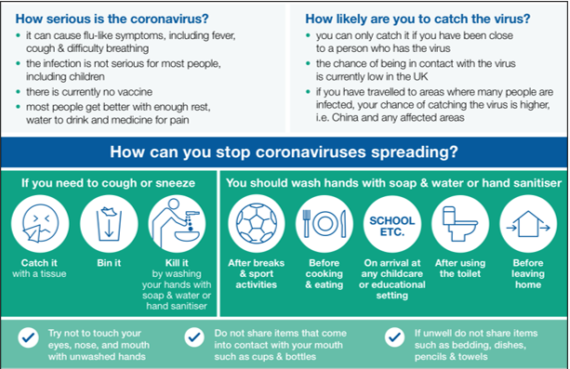
In summary, you should make sure you and your children follow these general principles to prevent spreading any respiratory virus:

- Wash your hands often – with soap and water for at least 20 seconds, or an alcohol-based sanitiser if soap and water aren’t available
- Avoid touching your eyes, nose, and mouth with unwashed hands
- Avoid close contact with people who are sick
- If you feel unwell, stay at home and don’t attend work or school
- Cover your cough or sneeze with a tissue, then throw the tissue in a bin. Follow the NHS guidance: ‘catch it, bin it, kill it.’
- Clean and disinfect frequently touched objects and surfaces in the home
- If you’re worried about your symptoms, please call NHS 111 – don’t go directly to your GP or other healthcare environment.

To conclude, if you suspect that your child may have COVID-19, or that they may have a sibling or family member that they are in close contact with who has a suspected case of COVID-19, you should call the NHS on 111 immediately or 999 in an emergency. Your child should also stay away from school, following the government advice regarding self isolation, and the school should be informed as soon as possible.

Further guidance for educational settings has been published at the following links and will be updated as soon as possible with the above advice and any further changes:
https://www.gov.uk/government/publications/guidance-to-educational-settings-about-covid-19

Information for the public: https://www.gov.uk/guidance/wuhan-novel-coronavirus-information-for-the-public

If you or your child have any further concerns or questions, please do not hesitate to contact me.

Yours sincerely
Mr Vaughan
Head teacher

