Friday 20 March 2020

Dear Parent/Carer,

Year 10 Home Learning

During this unprecedented time of a school closure we thank all parents for your continued support and we aim to provide as much clarity and information as possible during this time. Whilst our Priory students are temporarily based at home we are committed to providing every student with a high quality home learning experience. The lessons we will be providing students with, will be focused on consolidation tasks and applying existing knowledge.

All information regarding our home learning programme will be accessible via the Priory school website. Please go to the ‘Students’ menu and then select the ‘Home Learning’ page. This page will go live by Monday morning.

Show My Homework
All lessons will be accessed via show my homework, therefore all students must log in to show my homework every day, via the following web link: https://www.satchelone.com/login. Each student has been provided with their personal log in details. Lessons will be uploaded daily, and there is an expectation for students to be completing the work on the day that it is set.
Feedback where appropriate will be provided to students. There is guidance on our website to support students uploading specific pieces of work for the teacher to provide feedback.

Timetable per year group
The home learning lessons will be set via show my homework, and will follow the following timetable for each year group.

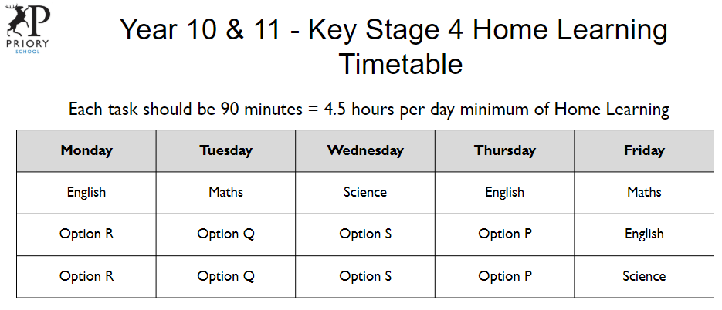
GCSE options. Each option block indicates a different subject. It will be clear when your son/daughter logs into show my homework which option subject has set work for that day.
Parent communication with school
Please refer to the website and download the MyEd app to support communication. All queries including IT should ideally be sent through the MyEd app or via the following link.
tempithelp@priorysouthsea.org

Student communication with school
If your child needs to communicate with school, please ask them to email their progress leader.
Year 10 - Mrs Fairs - sfairs@priorysouthsea.org
Leadership Link - svaughan@priorysouthsea.org

In addition many students have key members of staff who support them in and around lessons, their contact details are below;

Mrs Hughes - khughes@priorysouthsea.org
Mrs K Williams - kwilliams@priorysouthsea.org
Mrs M Lewis - mlewis@priorysouthsea.org
Miss L Murphy - lmurphy@priorysouthsea.org
Miss K Strong - kstrong@priorysouthsea.org
Miss K Misselbrook - kmisselbrook@priorysouthsea.org

School communication home
Work will be set on a daily basis. Furthermore, we are aiming to call every household once a week to check on welfare and maintain a link between home and Priory.

We are resolutely committed to maintaining education for your children and look forward to seeing your children again very soon. Please stress to your children, with their final year fast approaching, that it is imperative that they keep up to date with their work.

Please stay safe and look after each other.

Yours sincerely


Mr Vaughan
Head Teacher

