01 April 2020

Dear Parents/Carers

Vivid Homes offer to support home learning with donation of computer devices

As you may be aware, Priory School, as part of Bohunt Education Trust (BET), is trying to help children who may not have access to a laptop, iPad or other device, to get online during this unprecedented time.

This week, we have been incredibly fortunate to have had an offer of support from Vivid Homes, Hampshire’s largest provider of affordable homes.

Vivid is offering a limited supply of tablets and computers, including some with free 4G internet connectivity, to families with a child or children living in a Vivid property without access to a suitable device for school work – i.e. no access to a suitable computer or tablet.

This opportunity could be game-changing for students who are unable to fully access our home learning curriculum.

If you live in a property owned by Vivid Homes and have a child who does not have the equipment they need to do schoolwork at home, please call Vivid directly on the number on the attached flyer – 023 92 063327. When you call, please let Vivid know the name of the school your child attends so that we can keep track of how many BET students are in receipt of this brilliant offer, and so that we can monitor which children may still need support.

If you have any questions about this opportunity, please email me at school.

If you are interested in donating your old or used devices to BET, so that they can be used to help other children get online, please visit: https://www.bohunttrust.co.uk/news/bet-calls-for-old-ipads-chromebooks-and-laptops-to-support-online-access-for-children/ to learn more.

Take care and look after each other.
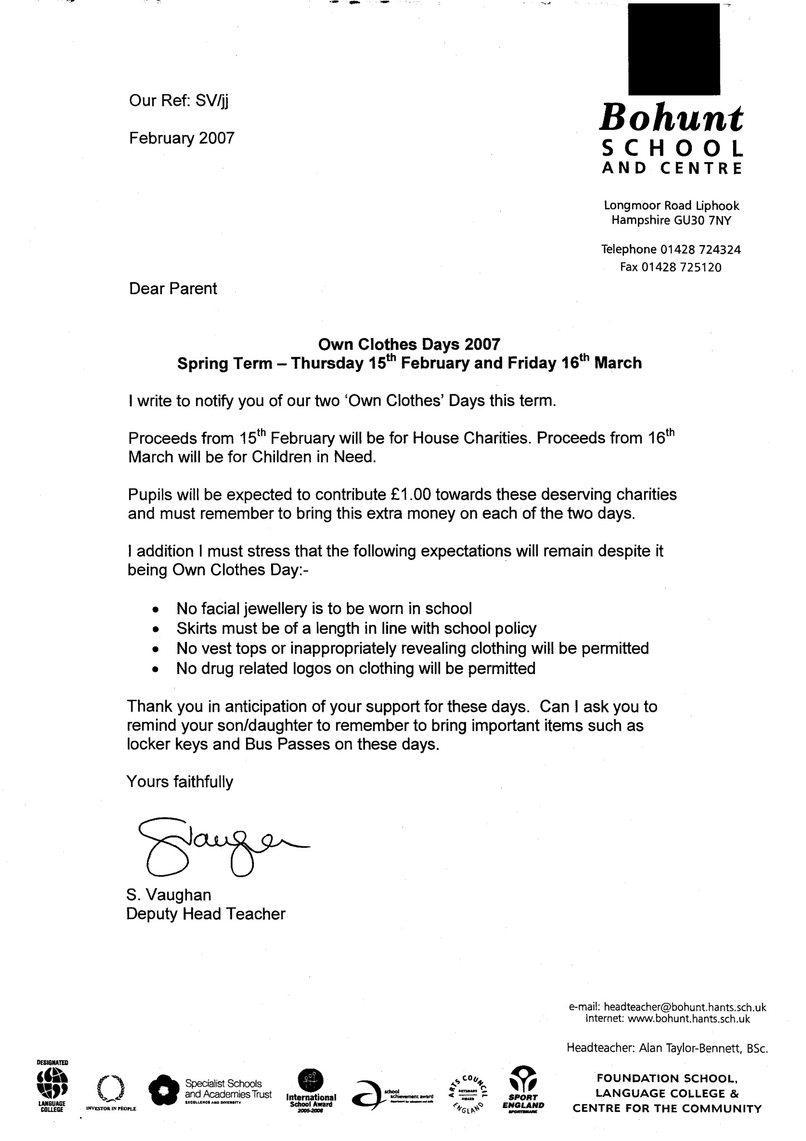

Mr Vaughan
Headteacher
priory@priorysouthsea.org

