May 2020

Dear Parents and Carers

Firstly, may I warmly welcome you to the Priory Community and thank you for entrusting us with your child’s secondary education.

Ordinarily, we would be sharing with you details of the Induction process ahead of your child starting with us in September, however, these are no ordinary times. Despite these extraordinary circumstances you are very much in our thoughts and our plans. The Induction process will continue and we hope to ensure that there is the opportunity to invite children into Priory School (including additional support visits for students with SEND or additional needs) ahead of their formal start date.

We will shortly be communicating with Year 6 teachers to find out any important information about our new students. However, if there is anything you feel you need to personally discuss about the move to Secondary school, please do let us know (ewilliams@priorysouthsea.org Emma Williams our Assistant Headteacher for Student Wellbeing or abusby@priorysouthsea.org Alison Busby our SENCO). We understand that the process can be daunting in any year and really do want to make it as positive and exciting as possible for everyone this year.

We will be in touch once again as soon as we have further information to share, until then do not hesitate to be in contact should you have any questions. For efficient communication do share with us an email address we may use for further correspondence by emailing Emma or Alison.

We look forward to meeting you and your child as soon as we are able to.

Yours sincerely
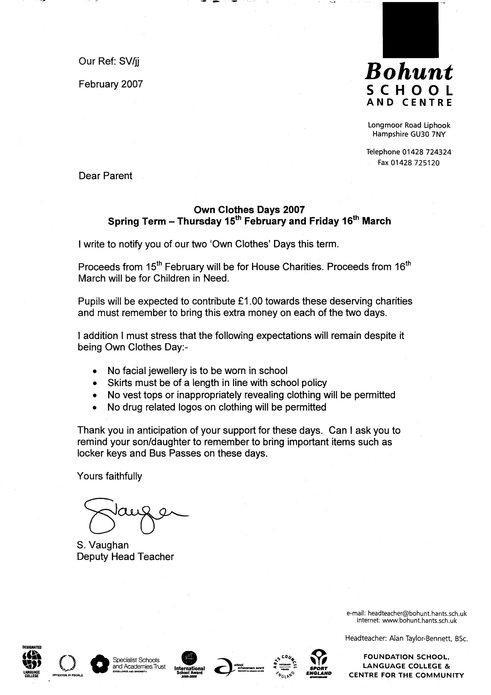

Stewart Vaughan
Headteacher




