
Year 9 Live Lesson Timetable
Monday 13th to Thursday 16th July 2020

Monday 13th July
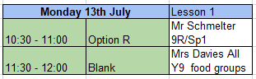
Tuesday 14th July
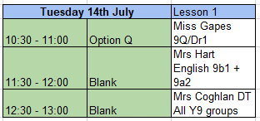
Wednesday 15th July
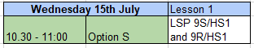
Thursday 16th July
