October 2020

Dear Parents and Carers

Year 11 Parents’ update

The students have had a very positive start to the year and as we now approach the first round of mock examinations, I thought it a prudent time to write and communicate some recent and upcoming events, along with details of how we can support you and your child over the coming months.

Year 11 Information website launched September 2020
We set up a Year 11 Information website which can be accessed here:
https://sites.google.com/priorysouthsea.org/prioryschoolyr11information/home

This includes:

- Examination Information
- Core Information Videos
- Revision ideas, including Knowledge Organiser Information.

Changes to exams in 2021
You may have seen in the news that the examinations for 2021 have been delayed by three weeks in the summer. While we welcome this change, we are also conscious that students did miss more than three months of education. However, with the robust plans in place to support our students, we are confident our Year 11s will achieve the very best results they can.

Please do not underestimate the impact your support and encouragement has during this time and the help you may be able to give your child. If you are unsure how you can help your child, please look at the Year 11 website or contact Mr Foster, Mrs Fairs or Mr Rackley and they will be able to offer guidance.

Revision folders and record cards
Students are encouraged to keep revision folders and some record cards to help them organise their revision. They will be completing revision cards in tutor time in preparation.

Mock examinations
These begin on 16 November and last for two weeks. This is our first round of mock examinations. This process is to provide students with an authentic examination experience, and staff with further evidence of areas of strength and development to aid planning in the final months. Students will have to work hard and manage their time well but we also understand that we need to help them manage that time. Please find attached the mocks timetable that all students have been issued with.

Period 6
Period six sessions will not run during the Mock Examinations.

Homework
We expect students to be revising at home during the mocks and tasks will be set to aid this. There will be no homework set for the two weeks immediately following the Mock Exams.

Other important dates for this half term

Year 11 results event:

17 December 2020

INSET days

07 December 2020

08 December 2020

School closed to all students on these days. No clubs or after school lessons will run on these days.

Thank you for your continued support at this crucial time in your child’s education.

Yours sincerely
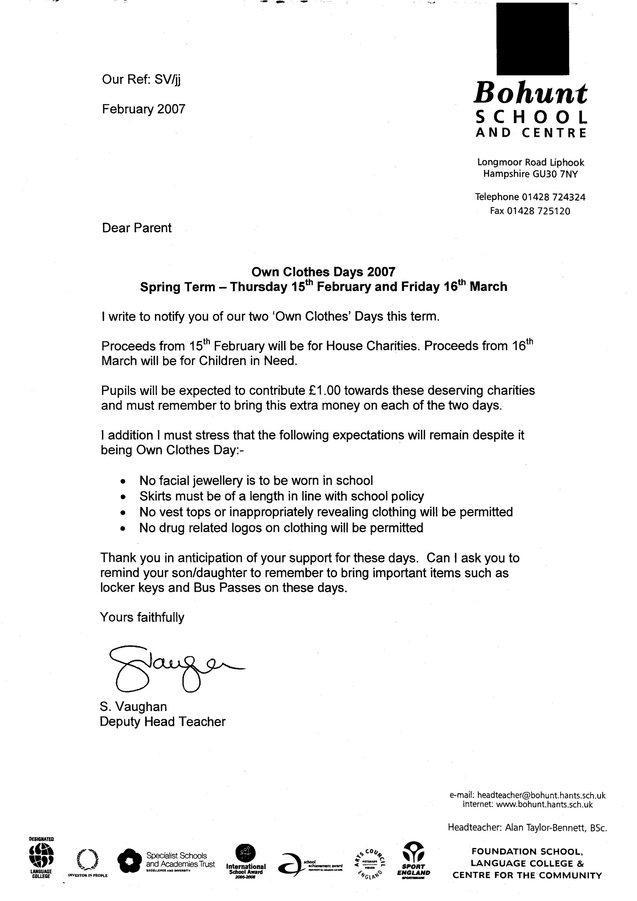

S Vaughan

Head teacher

