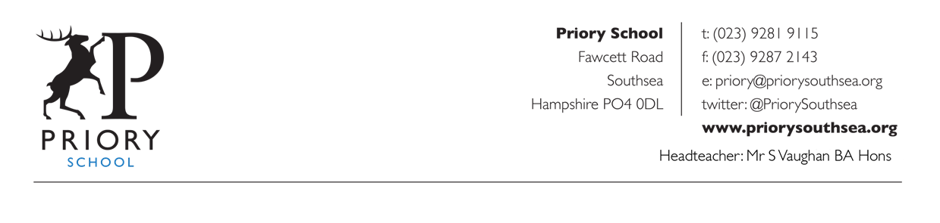
November 21 2020

Dear Parent/Carer,

Re: Year 8 Advice for child to self-Isolate for 14 days

We have been advised by Public Health England that there has been a confirmed case of COVID-19 within the school. Having considered carefully the movements of the year group I have made the decision that, on this occasion, the whole year group will have to isolate in line with Public Health advice.

In line with the national guidance we recommend that your child now stay at home and self-isolate until Thursday 3 December as this is 14 days after the individual displayed first symptoms. If your child is well at the end of the 14 day period of self-isolation and has not shown symptoms or tested positive in the meantime, then they can return to usual activities and return to school on Friday 4 December.

We are asking you to do this to reduce the further spread of COVID 19 to others in the community.

Other members of your household can continue normal activities provided your child does not develop symptoms within the 14 day self-isolation period.

Please see the link to: Guidance for contacts of people with confirmed coronavirus (COVID-19) infection who do not live with the person
https://www.gov.uk/government/publications/guidance-for-contacts-of-people-with-possible-or-confirmed-coronavirus-covid-19-infection-who-do-not-live-with-the-person

Home Learning

- All Year Eight lessons will be delivered online. Where staffing allows these lessons will be live and students will be expected to be in attendance for all of their lessons. Please see the timetable below to see which lessons are scheduled throughout each day. Your child should consult their usual individual in school timetable so see which option lessons they have during the option lessons scheduled.
- Lessons will be delivered via Zoom and will typically be 30 minutes of direct instruction followed by activities for completion. Links for the Zoom lesson & additional activities will be available via Show My Homework on each day and students can interact with their teachers via Show My Homework about these tasks.
- Students should log in to Zoom and their screen name should be what would normally be used on the school register.
- Some lessons will be delivered by subject specialists who are not your child’s usual teacher.
- Microphones should be muted. Cameras remain on for registration only then turned off.
- Normal classroom behavioural expectations will apply.

Where a Zoom lesson is not possible because of staff absence/illness a full lesson of work will be posted on Show My Homework

We are sorry for this disruption but will do everything we can to support your child during this period and thank you for your understanding and support.

Digital support

We will provide additional support to families who have indicated that they have problems accessing appropriate IT in our recent surveys.

If your circumstances have recently changed and you feel that you now require additional support then please use the email address below to let us know.

If your child will have issues accessing online learning please let us know using the following email address: priory@priorysouthsea.org

Free School Meals

We will provide food packages for students who are on Free School Meals. Communication will be made on Monday 23 November to arrange delivery of these packages.

Pastoral support

Further additional enquiries should be via Year Eight Progress Leader, Mrs Robinson.
nrobinson@priorysouthsea.org

What to do if your child develops symptoms of COVID 19

If your child develops symptoms of COVID-19, they should remain at home for at least 10 days from the date when their symptoms appeared. Anyone with symptoms will be eligible for testing and this can be arranged via https://www.nhs.uk/ask-for-a-coronavirus-test or by calling 119.

All other household members who remain well must stay at home and not leave the house for 14 days. This includes anyone in your ‘Support Bubble’.

The 14-day period starts from the day when the first person in the house became ill.

Household members should not go to work, school or public areas and exercise should be taken within the home. If you require help with buying groceries, other shopping or picking up medication, or walking a dog, you should ask friends or family. Alternatively, you can order your shopping online and medication by phone or online.

Household members staying at home for 14 days will greatly reduce the overall amount of infection the household could pass on to others in the community.

If you are able to, move any vulnerable individuals (such as the elderly and those with underlying health conditions) out of your home, to stay with friends or family for the duration of the home isolation period

Please see the link to the PHE ‘Stay at Home’ Guidance:
https://www.gov.uk/government/publications/covid-19-stay-at-home-guidance/stay-at-home-guidance-for-households-with-possible-coronavirus-covid-19-infection

Symptoms of COVID 19

The most common symptoms of coronavirus (COVID-19) are recent onset of:

- new continuous cough and/or
- high temperature and/or
- a loss of, or change in, normal sense of taste or smell (anosmia)

For most people, coronavirus (COVID-19) will be a mild illness.

If your child does develop symptoms, you can seek advice from the nhs.uk website at https://www.nhs.uk/conditions/coronavirus-covid-19/check-if-you-have-coronavirus-symptoms/. If you are concerned about your child’s symptoms, or they are worsening you can seek advice from NHS 111 at https://111.nhs.uk/ or by phoning 111.

How to stop COVID-19 spreading

There are things you can do to help reduce the risk of you and anyone you live with getting ill with COVID-19

Do
- wash your hands with soap and water often – do this for at least 20 seconds
- use hand sanitiser gel if soap and water are not available
- wash your hands as soon as you get home
- cover your mouth and nose with a tissue or your sleeve (not your hands) when you cough or sneeze
- put used tissues in the bin immediately and wash your hands afterwards

Further Information

Further information is available at
https://www.nhs.uk/conditions/coronavirus-covid-19/
Yours sincerely

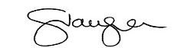

Stewart Vaughan
Head teacher

Year 8 Timetable

