31 December 2020

Dear Parents/Carers

As we approach the end of 2020 I hope this latest communication finds you well and you have been able to find some way to enjoy the festive season. I would not ordinarily communicate over a public holiday but, given the key government announcements yesterday, I wanted to provide as much notice as possible in advance of the start of term. We appreciate and apologise that this change comes at such short notice and may inconvenience you but it is essential that we closely follow Government guidance on COVID-19 in order to safeguard our students, staff and wider school community.

Changes to the start of term, January 2021

Yesterday the Secretary of State updated the guidance regarding the start of term in January and has advised that secondary schools in England should not fully re-open to all students and staff following the Christmas holidays.

We will begin term by running an INSET day on Monday 4 January. This will be to enable us to:
- Plan Live lessons
- Ensure households have appropriate devices
- Arrange Free School Meal Vouchers
- Organise school for Key workers and vulnerable students
- Take delivery of testing kits, organise and communicate our plans for testing the school community.

Priory School will then be open from Tuesday 5 January for students classed as vulnerable, and for children of key workers. Priory will remain closed for all other students, including year 11 who had previously been expected to return.

All students will receive their learning remotely for the first week of term (i.e. from 5 January) and they will be expected to engage fully with this. We do not regard yesterday’s announcement as an extension to the Christmas holiday and will begin a full programme of online lessons, as previously indicated, from Tuesday 5 January.

In summary:

From 5-8 January inclusive:
- All years should undertake remote learning from home, following their normal timetable
- Students that follow the definition as vulnerable should attend school
- Those children of keyworkers will be able to attend school if absolutely necessary.
From 11 January
- Year 11 should attend school for classroom lessons.
- Years 7-10 should undertake remote learning from home, following their normal timetable
- Students that follow the definition as vulnerable should attend school
- Those children of keyworkers will be able to attend school if absolutely necessary.
From 18 January

- All years should attend school for normal classroom lessons

We have additional devices to support students at home but we must have up to date information to provide that support. We will then endeavour to get those devices to you in time for the start of term on 5 January.

Parental survey

On the 18 December I asked that parents completed the survey below in order to get a clearer idea of the attendance, testing consent and IT needs for our students in the first weeks back.

My thanks to everyone who completed the survey. So far 300 of you have been kind enough to do so. Can I ask that the remaining parents do so as quickly as possible.

https://forms.gle/xytQeQMpKktb1rs4A

I will write with a further update on Monday 4 January and expect that there will be further updates, and potentially further changes, as our circumstances evolve in the coming days and weeks.

Thank you once more for your patience and support. I wish you all a safe and prosperous new year.

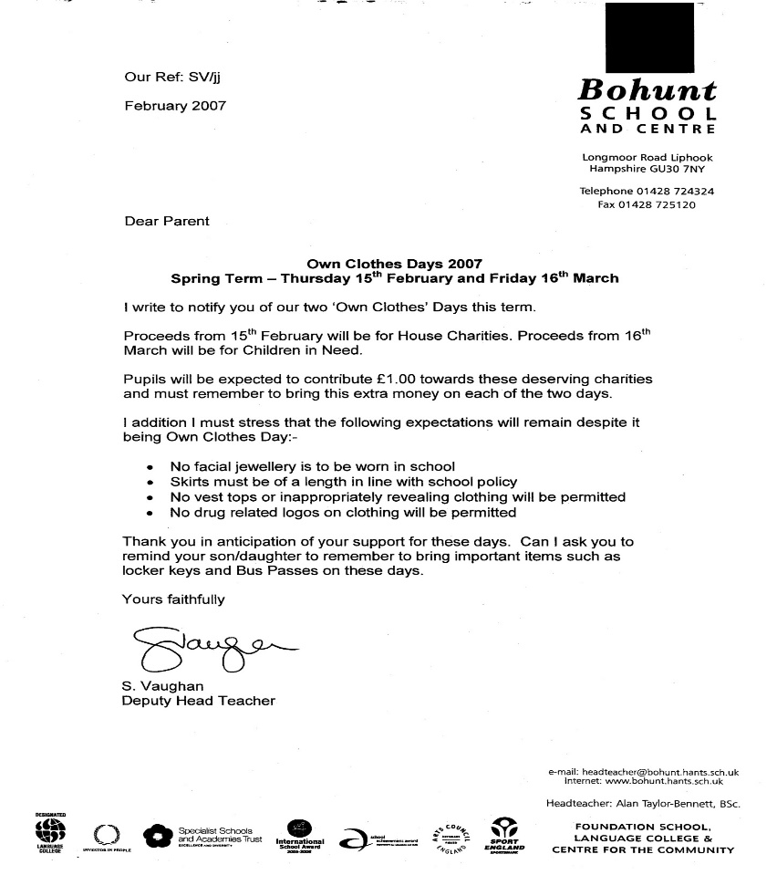

Mr Vaughan
Headteacher


